40.Design NFA to accept any number of b’s where input={a,b}.

INPUT:

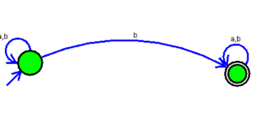

OUTPUT:

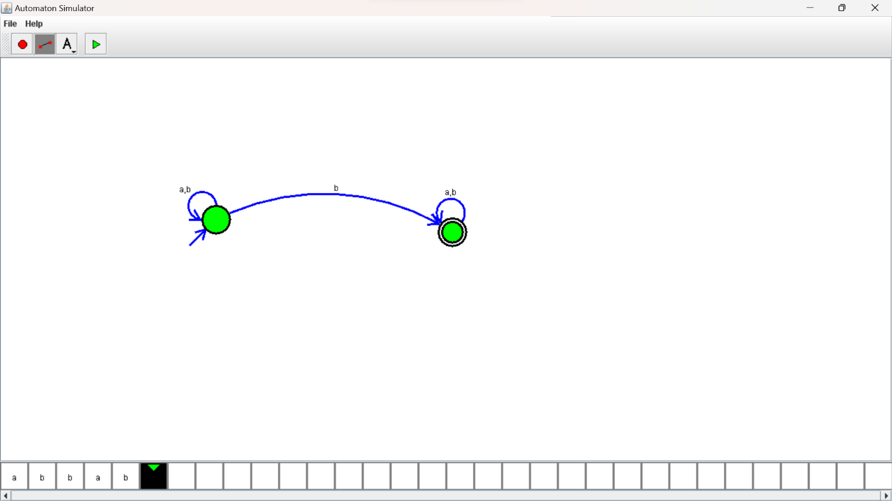

RESULTS:

NFA to accepting any number of b’s where input={a,b}.